**TASK-04**

**Increment and decrement in short int.**

**EXPLANATION:**

The program uses 2 functions in which it adds 1 in test value and subtract 1 from test value and displays the output.

**INPUT:**

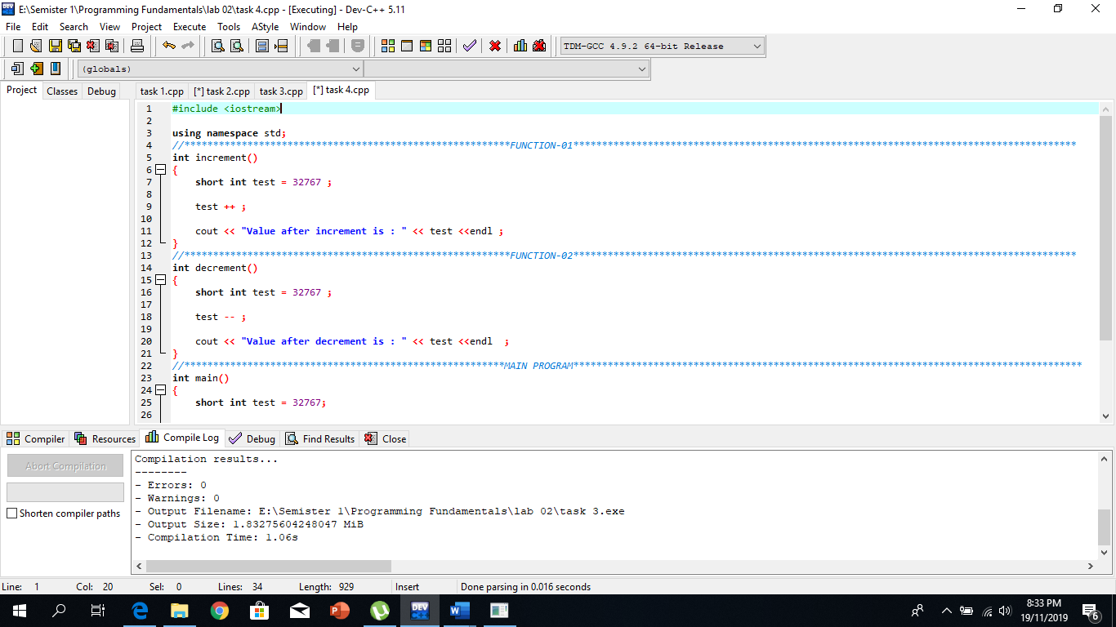

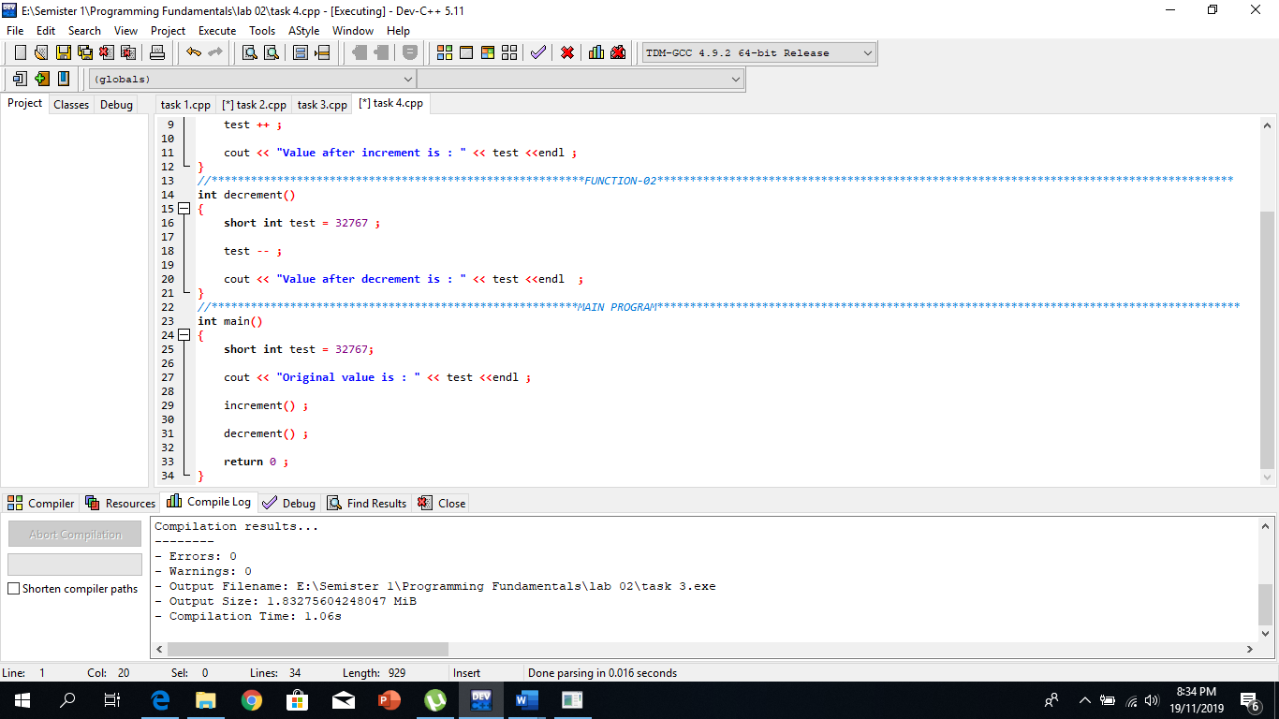

**OUTPUT:**

